CSA0618-DAA

Madhu Sudhan.D
192524214

Experiment 1: Linear Search
n = int(input("Enter number of elements: "))
a = list(map(int, input("Enter elements: ").split())) key = int(input("Enter key: "))

for i in range(n): if a[i] == key:
print("Key found at index", i) break
else:
print("Key not found")

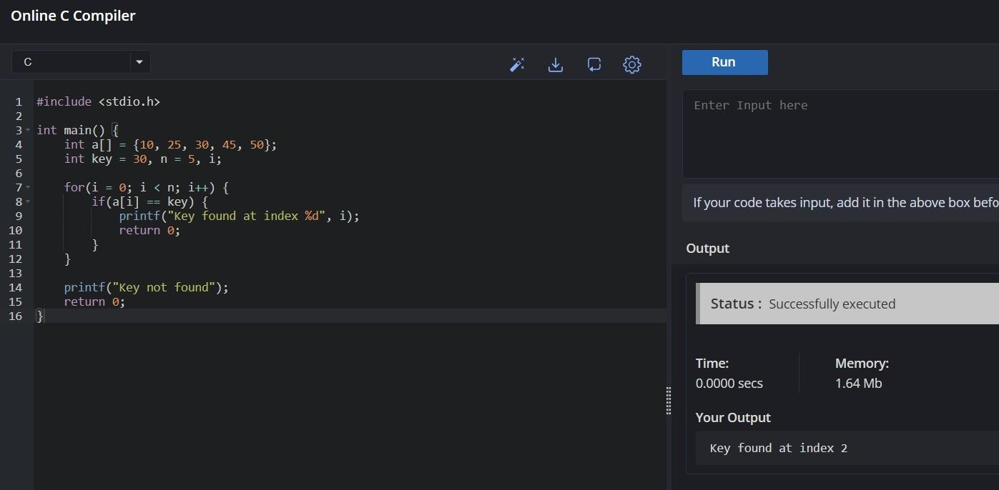

Experiment 2: Binary Search (Recursive) def binary_search(a, low, high, key):
if low > high: return -1

mid = (low + high) // 2

if a[mid] == key: return mid
elif key < a[mid]:
return binary_search(a, low, mid - 1, key) else:
return binary_search(a, mid + 1, high, key)

a = list(map(int, input("Enter sorted elements: ").split())) key = int(input("Enter key: "))

result = binary_search(a, 0, len(a) - 1, key)

if result != -1:
print("Key found at index", result) else:
print("Key not found")
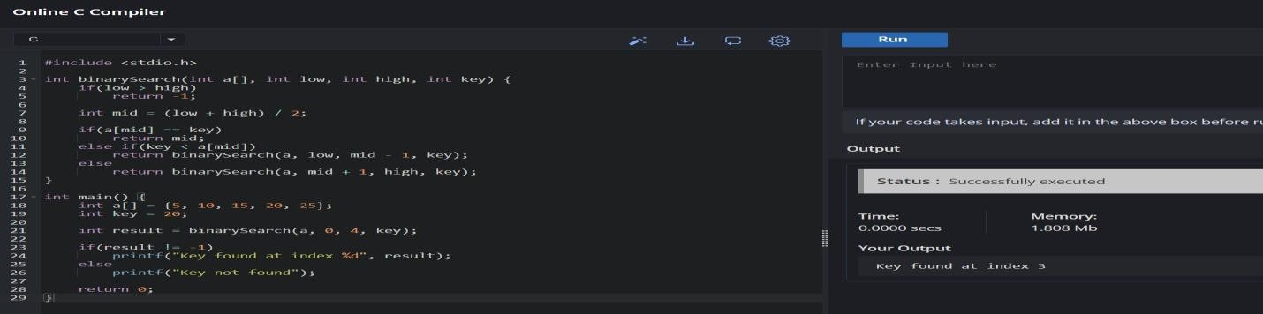

Experiment 3: Factorial – Iterative and Recursive
def factorial_recursive(n):
if n == 0:
return 1
return n * factorial_recursive(n - 1)

n = int(input("Enter n: "))

fact = 1
for i in range(1, n + 1):
fact = fact * i

print("Iterative Factorial =", fact)
print("Recursive Factorial =", factorial_recursive(n))

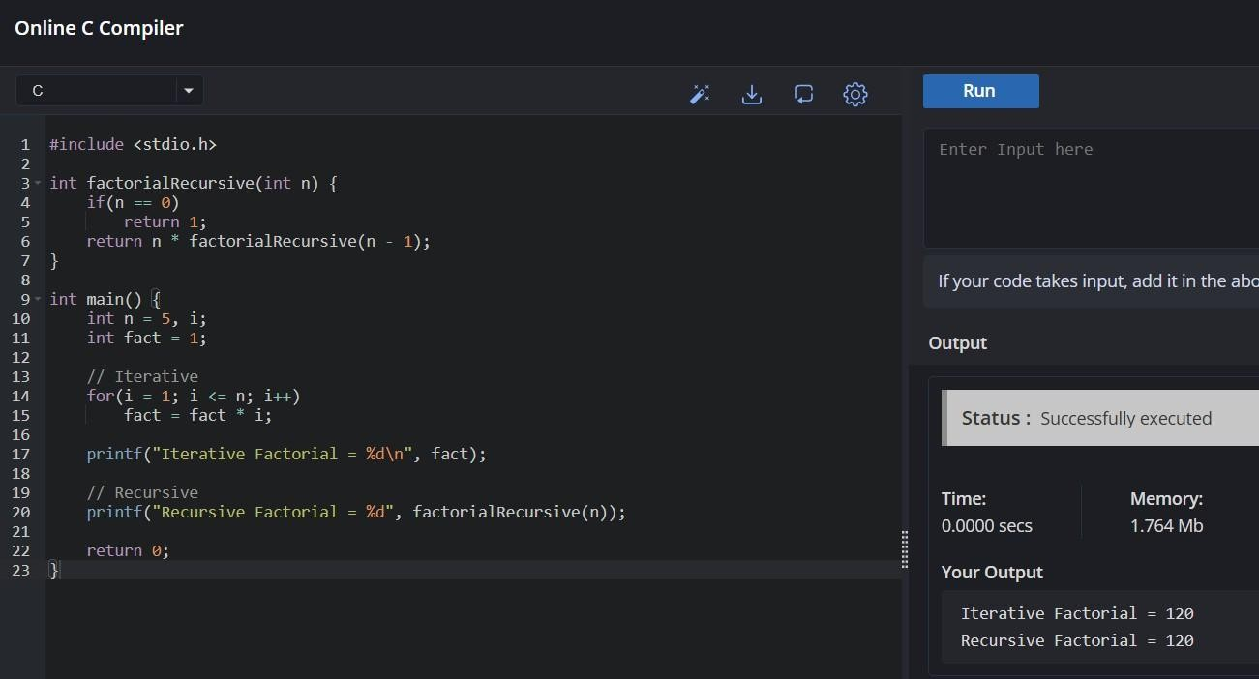

Experiment 4: Fibonacci Series
def fibonacci(n): if n <= 1:
return n
return fibonacci(n - 1) + fibonacci(n - 2)

n = int(input("Enter number of terms: ")) for i in range(n):
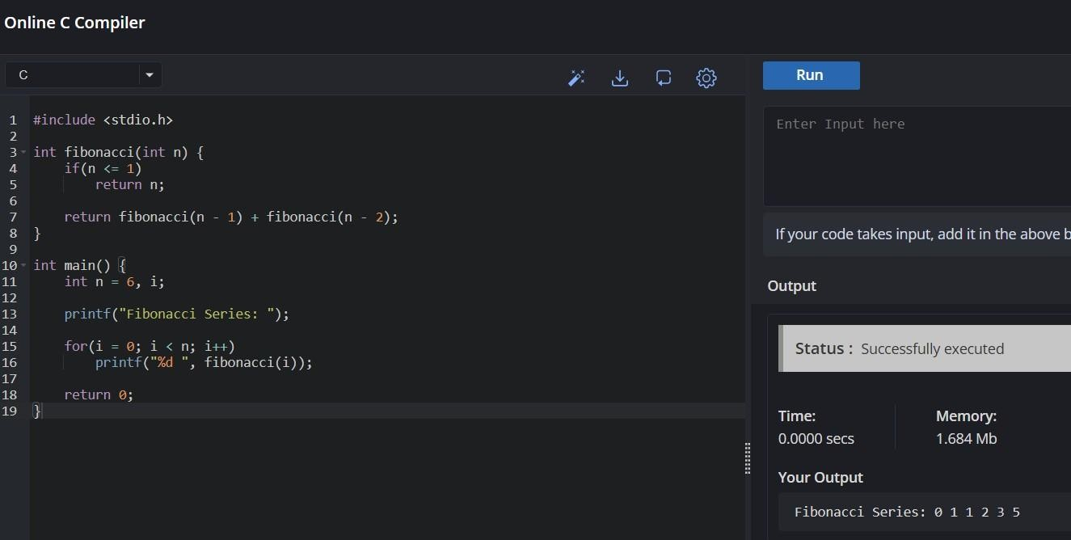
print(fibonacci(i), end=" ")

Experiment 5: Matrix Multiplication
r1 = int(input("Enter rows of first matrix: "))
c1 = int(input("Enter columns of first matrix: "))

A = []
print("Enter first matrix:") for i in range(r1):
- append(list(map(int, input().split())))

r2 = int(input("Enter rows of second matrix: "))
c2 = int(input("Enter columns of second matrix: "))

B = []
print("Enter second matrix:") for i in range(r2):
- append(list(map(int, input().split())))

C = [[0] * c2 for _ in range(r1)]

for i in range(r1):
for j in range(c2):
for k in range(c1):
C[i][j] += A[i][k] * B[k][j]

print("Result:") for row in C:
print(row)

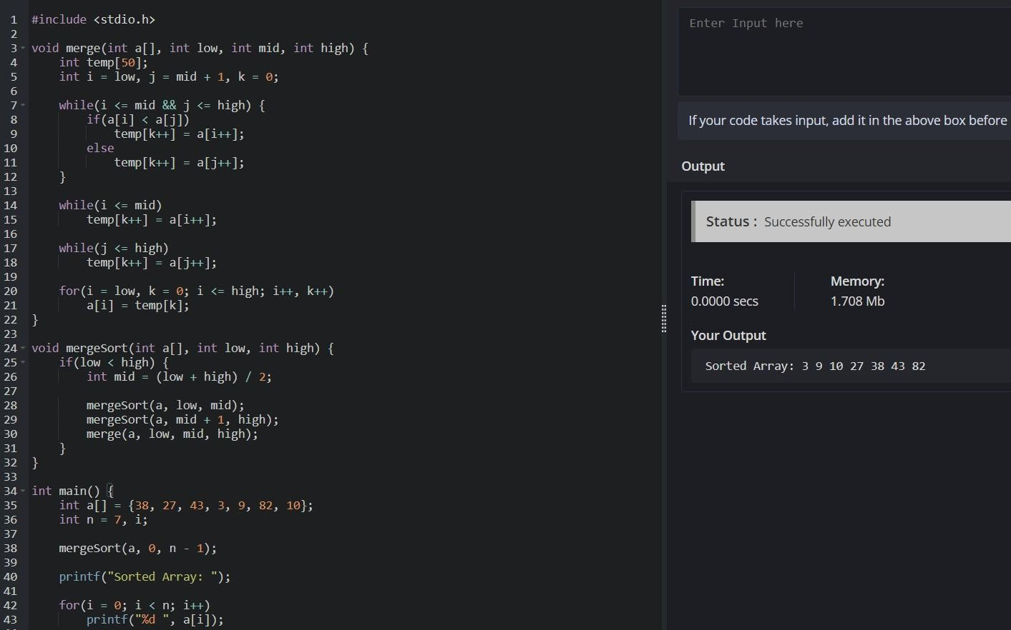

Experiment 6: Merge Sort
def merge_sort(a):

if len(a) <= 1:

return a

mid = len(a) // 2

left = merge_sort(a[:mid]) right = merge_sort(a[mid:])

result = [] i = j = 0

while i < len(left) and j < len(right): if left[i] < right[j]:
result.append(left[i]) i += 1
else:

result.append(right[j]) j += 1

result += left[i:] result += right[j:]

return result

a = list(map(int, input("Enter elements: ").split()))

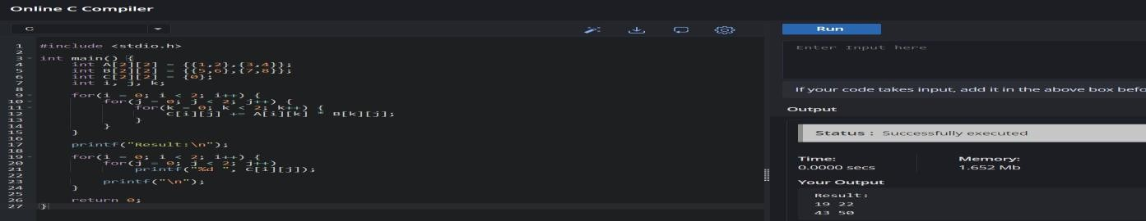
print("Sorted Array:", merge_sort(a))

Experiment 7: quick Sort
def quick_sort(a): if len(a) <= 1: return a

pivot = a[0]

left = [x for x in a[1:] if x <= pivot] right = [x for x in a[1:] if x > pivot]

return quick_sort(left) + [pivot] + quick_sort(right)

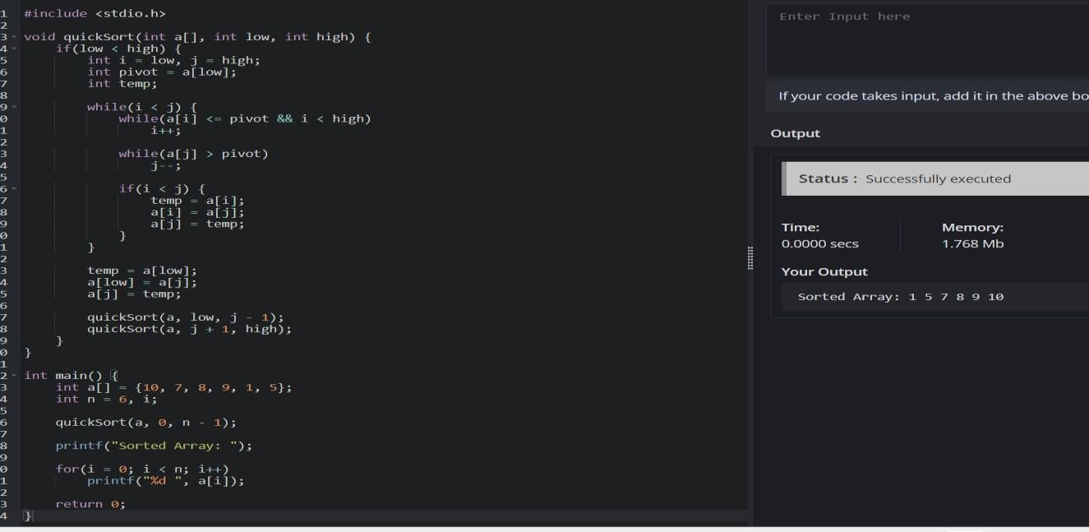
a = list(map(int, input("Enter elements: ").split())) print("Sorted Array:", quick_sort(a))

Experiment 8: Tower of Hanoi
def tower_of_hanoi(n, source, destination, auxiliary): if n == 1:
print("Move disk 1 from", source, "to", destination) return

tower_of_hanoi(n - 1, source, auxiliary, destination)

print("Move disk", n, "from", source, "to", destination)

tower_of_hanoi(n - 1, auxiliary, destination, source)

n = int(input("Enter number of disks: "))

tower_of_hanoi(n, 'A', 'C', 'B')

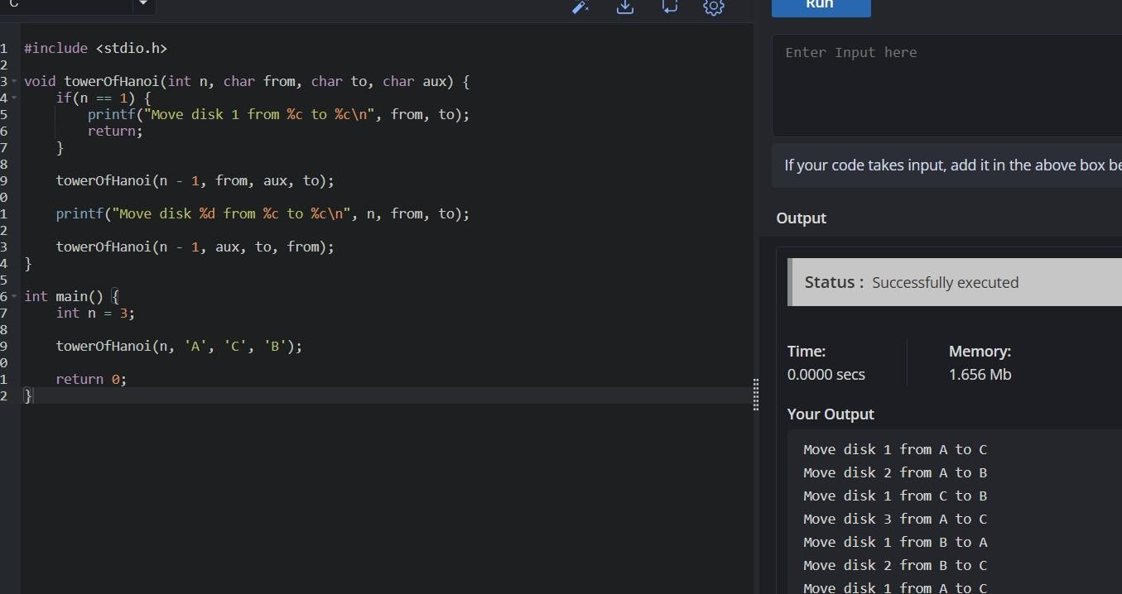

gcd and lcm
def gcd(a, b):

if b == 0:

return a

return gcd(b, a % b)

a, b = map(int, input("Enter two numbers: ").split())

print("GCD =", gcd(a, b))

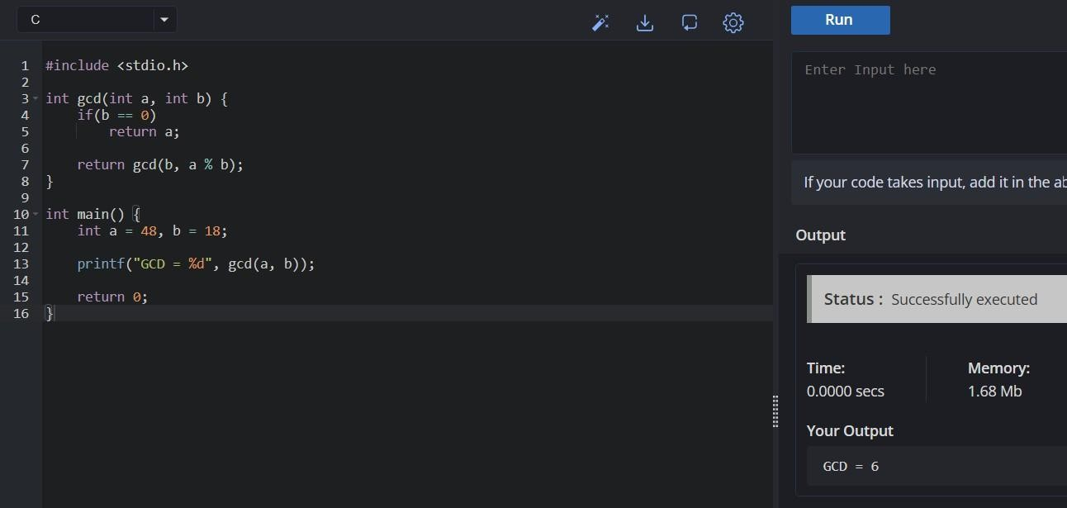

insertion sort
a = list(map(int, input("Enter elements: ").split()))

for i in range(1, len(a)): key = a[i]
j = i - 1

while j >= 0 and a[j] > key: a[j + 1] = a[j]
j -= 1

a[j + 1] = key

print("Sorted Array:", a)
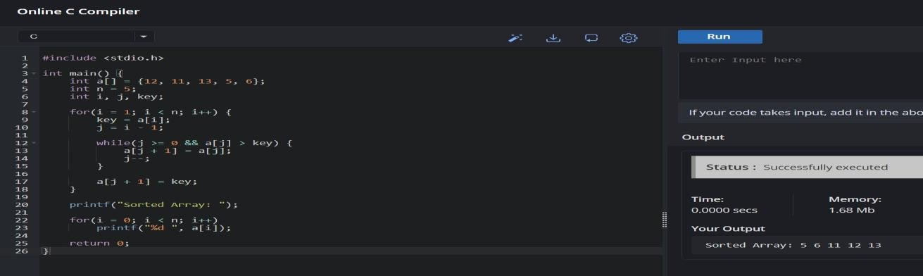

Heap sort
import heapq

a = list(map(int, input("Enter elements: ").split()))

heapq.heapify(a)

sorted_array = []

while a:
sorted_array.append(heapq.heappop(a))

print("Sorted Array:", sorted_array)
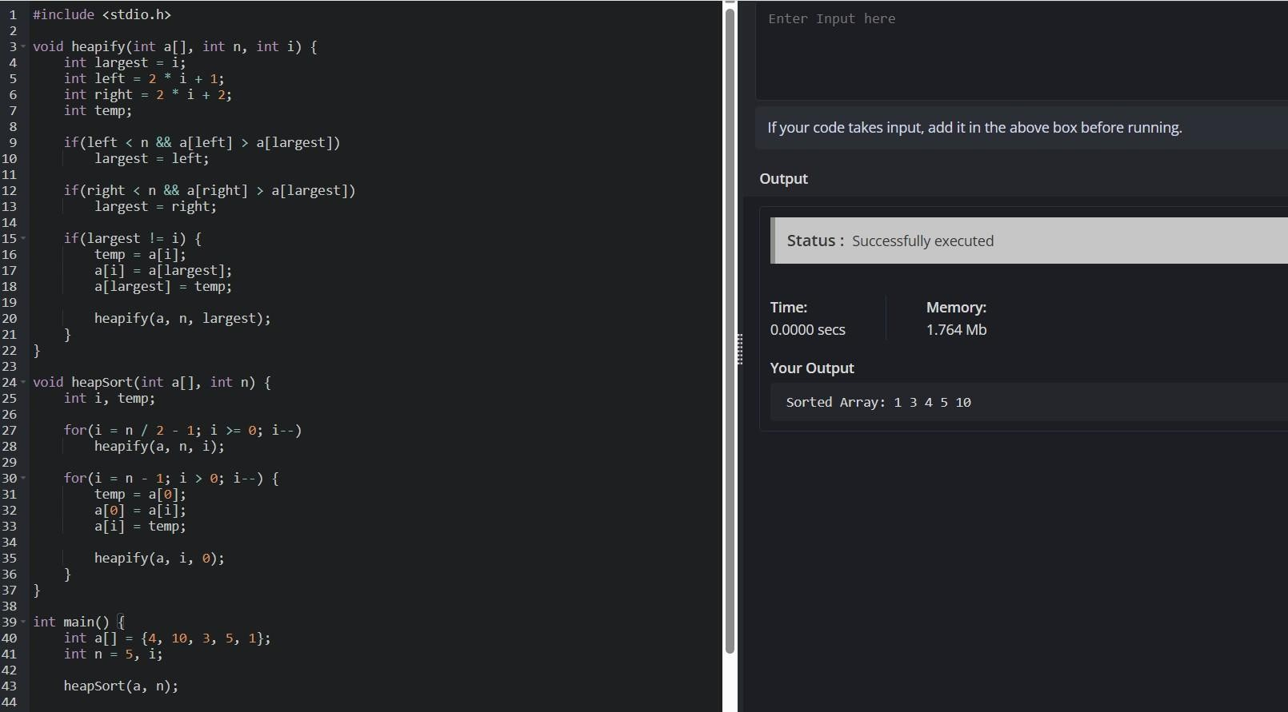

counting inversion
a = list(map(int, input("Enter elements: ").split()))

count = 0

for i in range(len(a)):
for j in range(i + 1, len(a)): if a[i] > a[j]:
count += 1

print("Number of Inversions =", count)

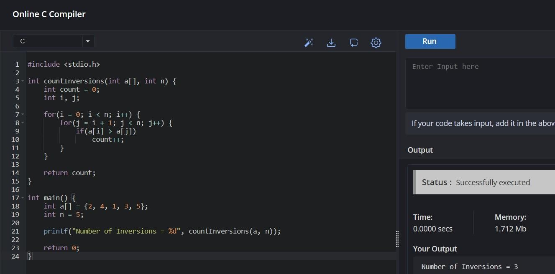

Experiment 13: Maximum Subarray Sum – Kadane's Algorithm
a = list(map(int, input("Enter elements: ").split()))

current = a[0] maximum = a[0]

for i in range(1, len(a)):
current = max(a[i], current + a[i]) maximum = max(maximum, current)

print("Maximum Subarray Sum =", maximum)

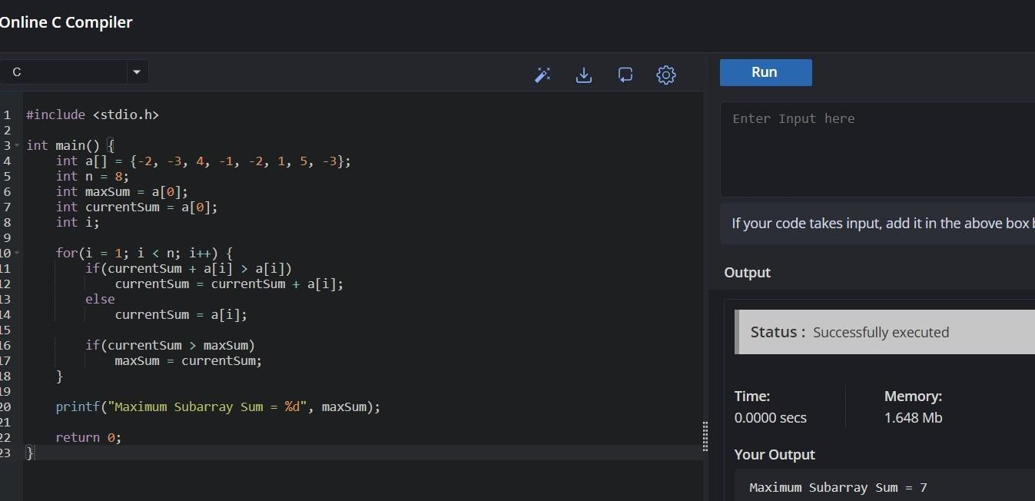

14: Exponentiation – Fast Power
def power(x, n): if n == 0:
return 1

if n % 2 == 0:
half = power(x, n // 2) return half * half

return x * power(x, n - 1)

x = int(input("Enter base: "))
n = int(input("Enter exponent: "))

print("Answer =", power(x, n))

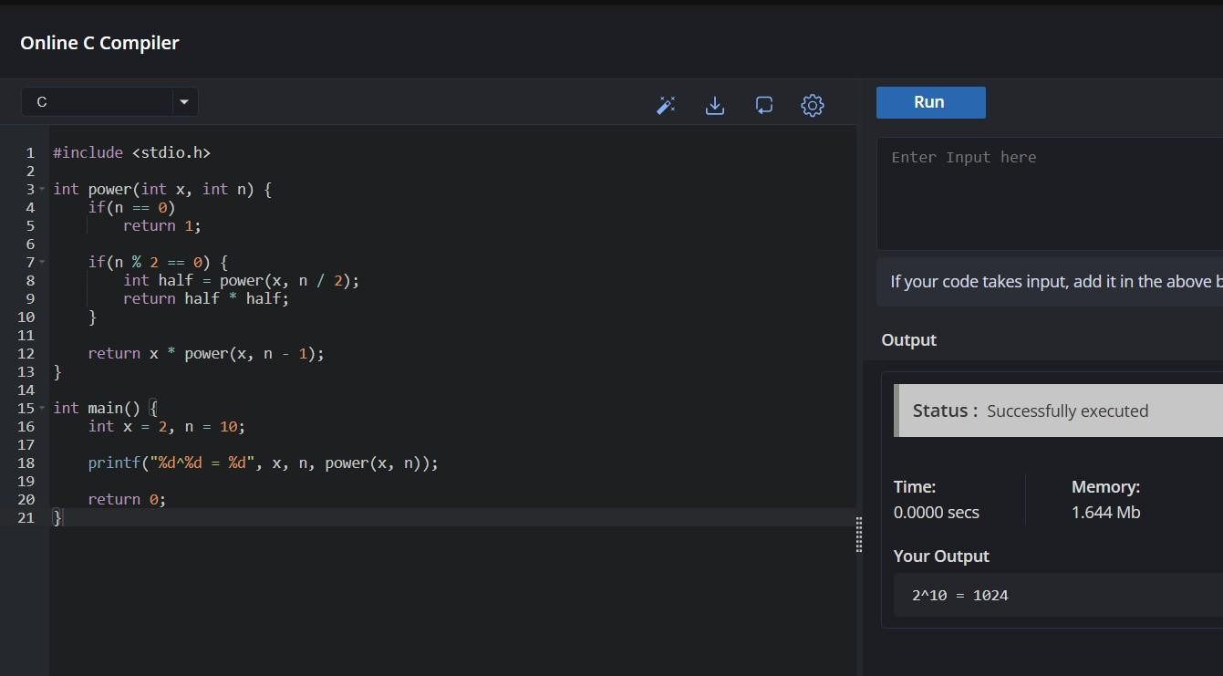

15.closest pair of elements
import math

n = int(input("Enter number of points: "))

points = []

print("Enter points:") for i in range(n):
x, y = map(int, input().split()) points.append((x, y))

minimum = float('inf') p1 = p2 = None

for i in range(n):
for j in range(i + 1, n):
distance = math.sqrt(
(points[i][0] - points[j][0]) ** 2 +
(points[i][1] - points[j][1]) ** 2
)

if distance < minimum:
minimum = distance p1 = points[i]
p2 = points[j]

print("Closest Pair:", p1, p2)
print("Distance =", round(minimum, 2))

